**Year 12 Human Biology**

**Extended Answer: Mechanisms**

**of Evolution**

|  |
| --- |
| Name: |
| Teacher: |

|  |  |  |  |
| --- | --- | --- | --- |
|  | Marks Received | Marks Available | Percentage |
| Question 1 |  | 10 |  |
| Question 2 |  | 10 |  |
| **TOTAL** |  | 20 |  |

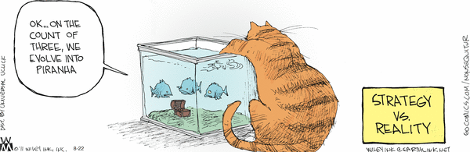

Weighting: 5% Assessment Time: 40 minutes

Complete your answers to the following questions on the pages provided

**Question 1: (10 marks)**

Harmful alleles which have arisen from a mutation affect the survival and reproduction of the individual and as a result, prevent them from passing on the allele. An example of this is Haemophilia. The Sickle Cell allele is also harmful, but has a very different outcome due to heterozygous advantage.

Compare and contrast natural selection with heterozygous advantage using these two examples.

**Question 2: (10 marks)**

Australian aboriginals migrated to Australia from Africa around 60,000 years ago. Studies have been done into blood group frequencies which show a great variation between the frequencies in Aboriginal groups and African negroes.

|  |  |  |
| --- | --- | --- |
| Blood Group | African Negros | Aboriginals |
| O | 48 | 66 |
| A | 27 | 34 |
| B | 21 | 0 |
| AB | 4 | 0 |

Discuss the likelihood of these differences arising due to natural selection, founder effect or genetic drift.

|  |
| --- |
|  |
|  |
|  |
|  |
|  |
|  |
|  |
|  |
|  |
|  |
|  |
|  |
|  |
|  |
|  |
|  |
|  |
|  |
|  |
|  |
|  |
|  |
|  |
|  |
|  |
|  |
|  |
|  |
|  |
|  |
|  |
|  |
|  |
|  |
|  |
|  |
|  |
|  |
|  |
|  |
|  |
|  |
|  |
|  |
|  |
|  |
|  |
|  |
|  |
|  |
|  |
|  |

|  |
| --- |
|  |
|  |
|  |
|  |
|  |
|  |
|  |
|  |
|  |
|  |
|  |
|  |
|  |

|  |
| --- |
|  |
|  |
|  |
|  |
|  |
|  |

|  |
| --- |
|  |
|  |
|  |
|  |
|  |
|  |

|  |  |
| --- | --- |
|  | |
|  | |
| |  | | --- | |  | |  | |  |  |  | | --- | |  | |  | |  | | |
|  |
|  |
|  |

|  |
| --- |
|  |
|  |
|  |
|  |
|  |
|  |

|  |
| --- |
|  |
|  |
|  |
|  |
|  |
|  |

|  |
| --- |
|  |
|  |
|  |